Programming classwork #2

Name: Alec Garza ID: R11927151

Problem-1 (Rectangle demo two)

____________________________________________________ package rectangle_demo__2;

public class Rectangle_demo_2 {

public static void main(String[] args) {

Rectangle r1 = new Rectangle(15, 20);

System.***out***.println("The width of rectangle r1 is: " + r1.getLength());

System.***out***.println("The area of rectangle r1 is: " + r1.getArea());

}

}

*- - - - - - - - - - - - - - - - - - - - - -*

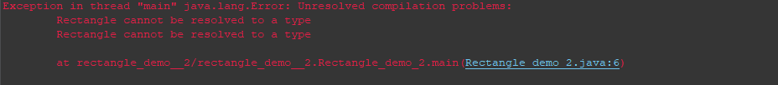

Problem-2 (Rectangle demo)

____________________________________________________ package rectangle_demo_;

/**

* This class demonstrates the use of the Rectangle class by allowing user input

* for the length and width of a rectangle and displaying its properties.

*/

import java.util.Scanner;

public class Rectangle_Demo {

public static void main (String[] args) {

Rectangle r1 = new Rectangle(); // Create a new Rectangle object

Scanner keyboard = new Scanner(System.in); // Scanner object to read user input

double len; // Variable to store the length of the rectangle

System.out.println("Please give an input for the length " + "of the rectangle: ");

len = keyboard.nextDouble(); // Read user input for length

r1.setLength(len); // Set the length of rectangle r1

System.out.println("The length of rectangle r1 is: " + r1.getLength()); // Display the length of rectangle r1

double w; // Variable to store the width of the rectangle

System.out.println("Please give an input for the width " + "of the rectangle: ");

w = keyboard.nextDouble(); // Read user input for width

r1.setWidth(w); // Set the width of rectangle r1

System.out.println("The width of rectangle r1 is: " + r1.getWidth()); // Display the width of rectangle r1

System.out.println("The area of the rectangle r1 is: " + r1.getArea()); // Display the area of rectangle r1

keyboard.close(); // Close the Scanner object

}

}

*- - - - - - - - - - - - - - - - - - - - - -*

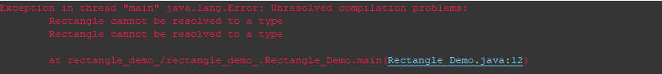

Problem-3 (Rectangle)

____________________________________________________ package rectangle;

public class Rectangle {

private double length;

private double width;

public void setLength(double len) {

length=len;

}

public void setWidth(double w) {

width=w;

}

public double getLength() {

return length;

};

public double getWidth()

{

return width;

}

public double getArea()

{

return width*length;

}

public Rectangle (double len, double w)

{

length = len;

width = w;

}

}